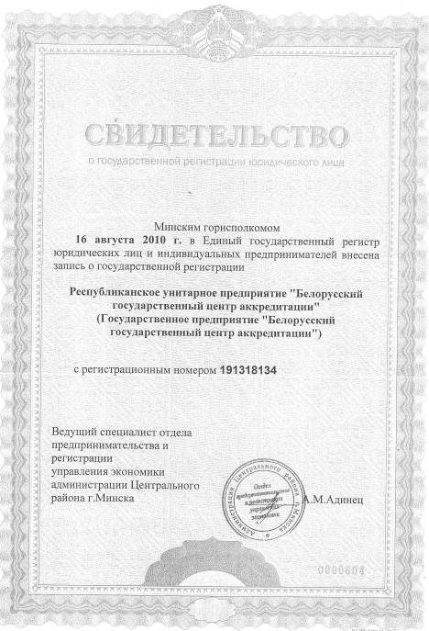

**CERTIFICATE**

of State Registration of Legal Entity

Minsk city executive committee

in **August 16, 2010** included the entry into the Unified State Register of legal entities and individual entrepreneurs

about the state registration of

**Republican Unitary Enterprise**

**«Belarusian State Centre for Accreditation»**

**(State Enterprise «Belarusian State Centre for Accreditation»)**

registration number **191318134**

Lead specialist of Department

of entrepreneurship and registration

Economic Governance of

Minsk Central district administration A.M.Adinets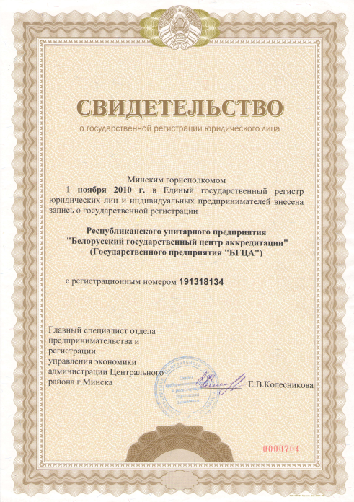

**CERTIFICATE**

of State Registration of Legal Entity

Minsk city executive committee

in **November 1, 2010** included the entry into the Unified State Register of legal entities and individual entrepreneurs

about the state registration of

**Republican Unitary Enterprise**

**«Belarusian State Centre for Accreditation»**

**(State Enterprise «BSCA»)**

registration number **191318134**

Chief specialist of Department

of entrepreneurship and registration

Economic Governance of

Minsk Central district administration E.V.Kolesnikova